FORMAL ASSESSMENT TASK 3: Year 3

ACTIVITY 1: LISTENING AND SPEAKING
Telephone etiquette: Have a telephone conversation between a customer and a company.

Rubric to assess listening and speaking: Telephone etiquette
Listening and speaking
25 marks
 | 12-15 | 7-11 | 4-6 | 1-3
Participation in a telephone conversation | Excellent timing, greeting, informative skills.  Excellent telephone etiquette.  Evidence of excellent rehearsal | Good timing, greeting, informative skills.  Good telephone etiquette.  Evidence of good rehearsal | Mediocre timing, greeting, informative skills.  Mediocre telephone etiquette.  Evidence of some rehearsal | Experience many challenges when answering and participating in a telephone conversation. Evidence of no rehearsal
 | 8-10 | 6-7 | 4-5 | 1-3
Ability to express self orally | Expresses her/himself very well. Able to say what he/she wants to say clearly and easily with few or no mistakes. | Expresses him/herself well. Able to say what he/she wants to say clearly and fairly easily, but with some mistakes. | Expresses him/herself with some difficulty. Struggles to say what he/she wants to say and makes many mistakes. | Struggles to express him/herself orally. Makes many mistakes. Difficult to understand. Says only one or two words.

ACTIVITY 2: READING AND VIEWING

1. Fill in the correct word. Choose from the word box. (10)

Communication is a two way process.
There is a sender the person sending the information and a receiver (the person receiving the information).
It is as if we talk in code and the receiver has to decode the message before he can understand it.
We respond based on what we think we have heard, our beliefs and our background

2. When we communicate we use the following: (3)
words, body language, tone of voice
3. Name 6 signs of positive body language. (6)
- Making eye contact
- Keeping our hands open as opposed to clenched
- Smiling
- Standing up straight
- Leaning towards the person we are listening to
- Turning our head slightly towards the person talking.

4. Circle the correct word in brackets.
4.1 Tone of voice is how we (do / say) something. (1)
4.2 Tone is very important in determining the (real / fake) message. (1)
4.3 It is important to keep our body language (negative / positive) (1)
4.4 “Rolling our eyes” is an example of (tone / body language). (1)
4.5 Clenched hands are a sign of (negative / positive) communication. (1)
4.6 Communication is a (one / two) way process. (1)
TOTAL: (25)

ACTIVITY 3: LANGUAGE STRUCTURES AND CONVENTIONS
QUESTION 1

Decide whether the sentence refers to a specific object and then fill in the correct article. Use either the, a or an to complete the sentences.
1. The Children’s Discovery book belongs to my brother. (1)
2. I live in the only green house in First Street. (1)
3. Do you have a pen for me? (1)
4. Do you have a ruler? (1)
5. Earth is a planet. (1)
6. I want an ice cream. (1)
7. May I have an apple? (1)
8. The new boy was late for school. (1)
9. Janet Smith is an artist. (1)
10. The Smiths are my neighbours. (1)
QUESTION 2
Fill in the correct demonstrative pronouns.
1 | This (that) | is my book. | 1
2 | These (those) | are my books. | 1
3 | That | is my car in the car park across the road. | 1
4 | Those | are cargo ships in the sea. | 1
5 | These | are my new shoes. | 1

QUESTION 3
I could not go to the concert because I was sick.
I wanted to play rugby but I left my boots at home.
My teacher was angry with me because I did not have a pen.
The test was easy but I failed it.
The dog looked friendly but it was vicious.
TOTAL: (25)

ACTIVITY 4: WRITING AND PRESENTING
QUESTION 1
Identify the three styles of communication and label the picture (3)
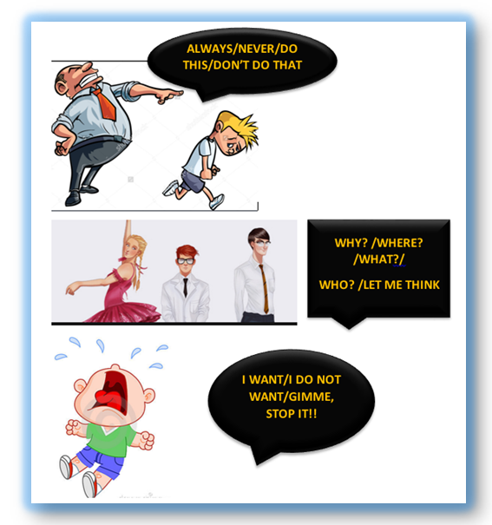
Parent

Adult

Child
.

QUESTION 2
Write the ego state for each of the following statements. (7)
Only write C / A / P. (It represents: Child, Adult and Parent).

1 | “A client is expecting the delivery this afternoon at 15:00. Can you please make sure it is done?” | A
2 | “Ah shame, are you not feeling good today?” | P
3 | “Can we discuss this?” | A
4 | “You always expect me to work late!” | C
5 | “How many times have I told you not to be late?” | P
6 | “I am unable to help you when you are interrupting me.” | A
7 | “You look tired, why do you not sit down?” | P

QUESTION 3 (6)
Read the following cartoons and say if the situations are Assertive / Non-Assertive or Aggressive.
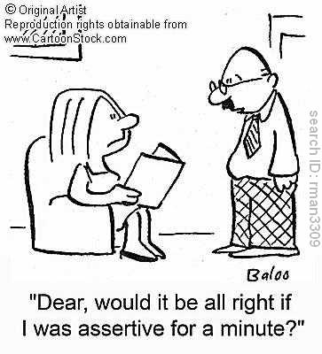

Non-Assertive

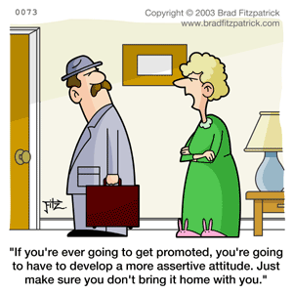
Aggressive

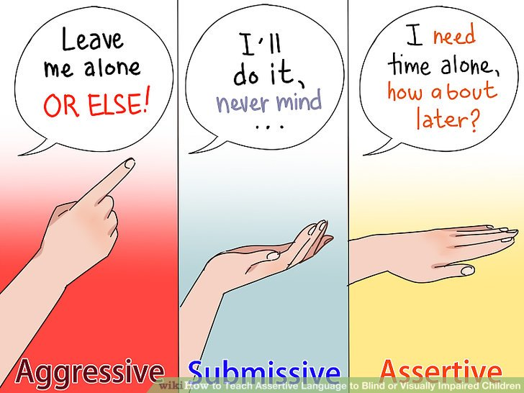
Assertive

Aggressive
Non-Assertive
Assertive

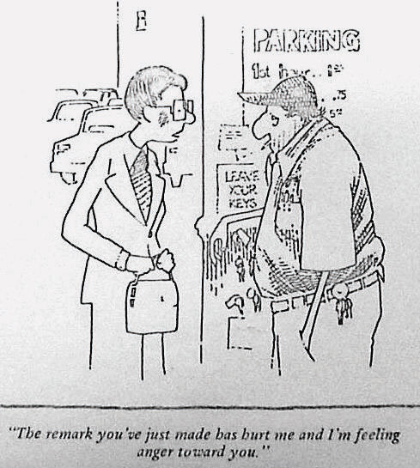

The remark you’ve just made has hurt me and I’m feeling anger toward you.
QUESTION 4 (4)
How do you use Honest, Open, Appropriate and Direct communication to give your message correctly?
Match the non-appropriate message to the appropriate message.
 | Appropriate message | Number
4.1 | “Please take this to John.” | 4
4.2 | “I would like to speak without interruption.” | 1
4.3 | “The punctuation in your report needs work.” | 3
4.4 | “I get mad when he breaks his promises.” | 2

QUESTION 5
Refer to the cartoon and in one paragraph explain the three states (5) of communication.

The mother communicates from a parent ego state when she says: “Hey, you with the dirty feet, outside!”
The child communicates from a child ego state when he says: “It’s not my fault”.
The mother could choose to communicate from an Adult ego state using logic, facts and reason by saying: “I have just washed the floor and your feet are dirty. Please go outside and clean them before you come in.”
Criteria |  | Marks | Achieved
Content | Names the three states of communication and gives an example from the cartoon. | 3
Language | Language and punctuation effectively used. | 1
Structure | Sentences and paragraph well constructed. | 1
TOTAL |  | 5

TOTAL: (25)

